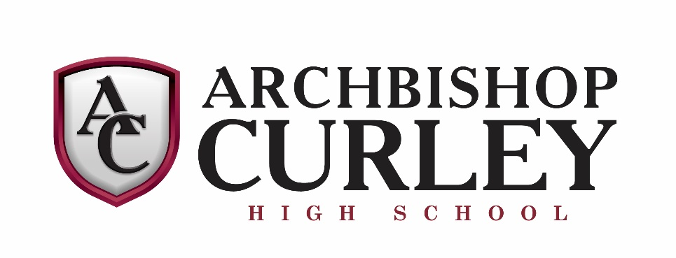
INSTRUMENTAL MUSIC
THE 2019-20 PERCUSSION ENSEMBLE

Director: Mr. Christopher Campbell

Jarvis Borromeo
Stephen Portera
Tre’Vel Flythe
Virgil Watson
Justin Lemmon
Hans Vonderhorst
Jesse Mangalapati
Caidon Oliphant
Parris Holland
Kyle Pumphrey
Andrew Ciresi
Timothy Villanueva

