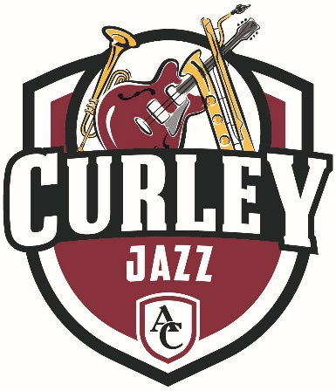
THE
ALUMNI BAND
All That Curley Jazz 2020

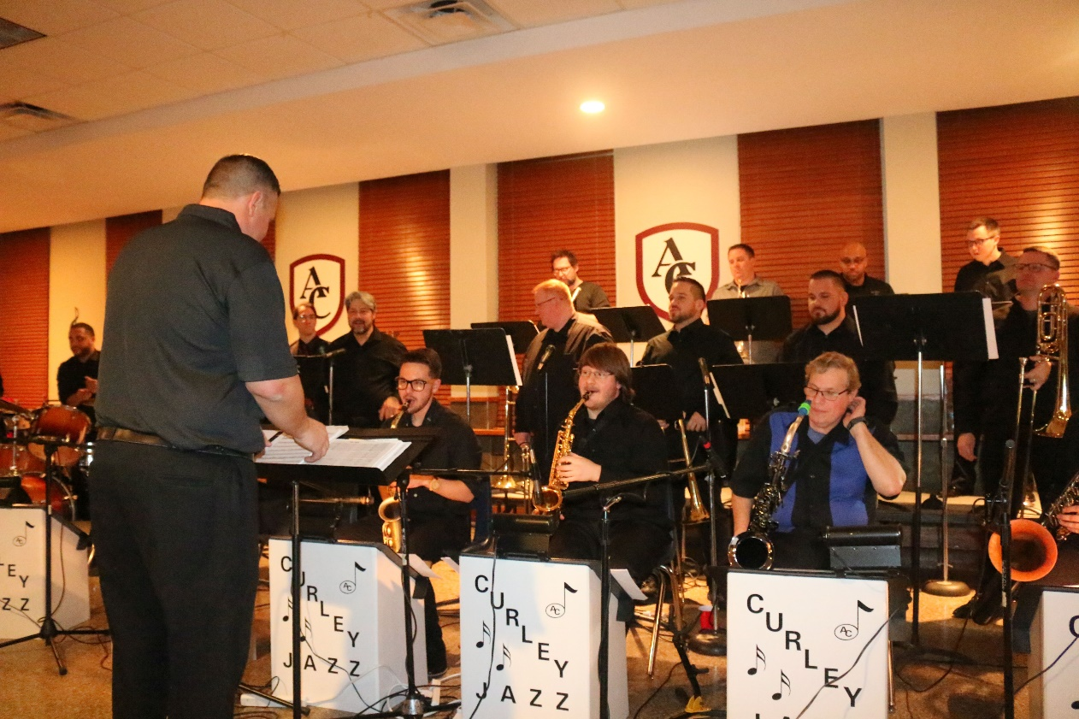
Saxophones: Matt Rynes '08, Dan Nakasone '17, Chris Young '11, Andrew Baker '13.
Trumpets: Dave Makowiecki '93, Ben Frock '98, Charles Wilson IV, '90, Charlie Bankard '90.
Trombones: Chris Rohe '93, Nick Mazziott '88, Tim Ridenour '09, Jeremy Ridenour '09, Steve Franzoni '84, Chris Campbell.
Rhythm: Chris Ruth '94, Charles Wilson '09, Rob Henry '92, Tyler Sosnowski '17, Nick Rynes '12.

