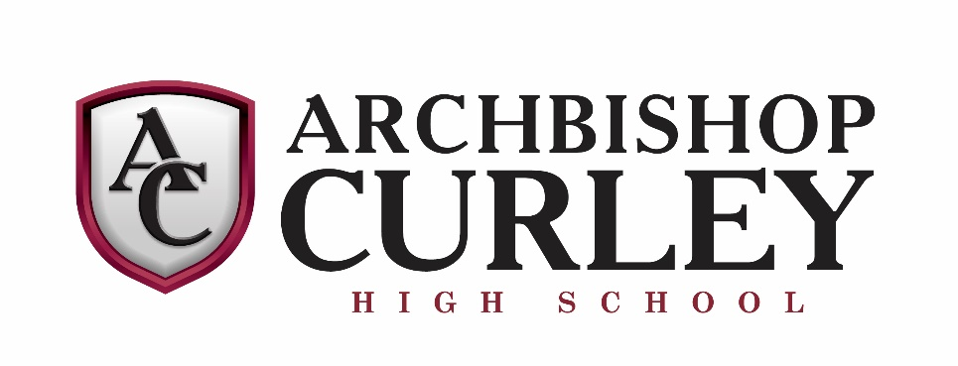
INSTRUMENTAL MUSIC
THE 2019-20 JAZZ ENSEMBLE
Director: Mr. Christopher Campbell

Piano
Michael Mann
Guitar
Josh Aung
Alto Sax
Samuel Zito
Scott Giampa
Tenor Sax
Samuel Walter
Ethan Fabyan
Baritone Sax
Russell Reside
Trumpet
Anthony Smith
Joseph Nakasone
Kyle Walker
Tyler Makowiecki
Trombone
Lucas Campbell
Ryan Seay
Jacob Brown
Nathan Barton
String Bass
Exekiel Ober
Percussion
Kyle McElwee
Auxilliary
Timothy Villanueva
Sound
Holden Carter
Erich Vonderhorst
Hans Vonderhorst

