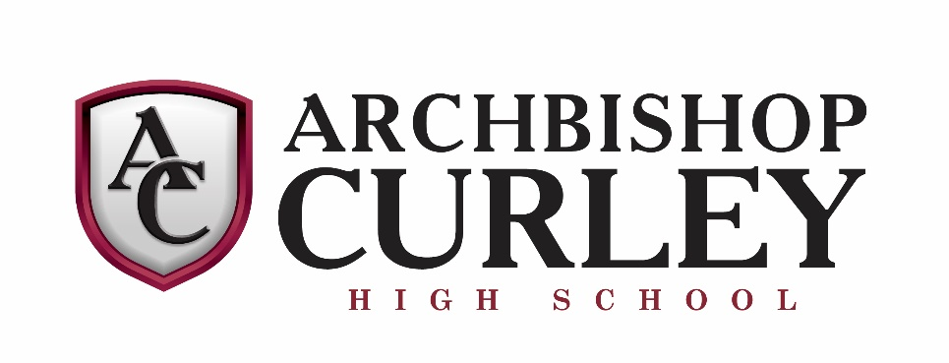
INSTRUMENTAL MUSIC
THE 2019-20 JAZZ LAB
Director: Mr. Christopher Campbell

Piano
Hans Vonderhorst
Guitar
Kyle McElwee
Saxophones
Samuel Zito
Greg Makerowicz
Michael Mann
Samuel Walter
Ethan Fabyan

Trumpet
Kyle Walker
Tyler Makowiecki
Holden Bower
Gaddiel Handy
Trombone
Lucas Campbell
Ryan Seay
Jacob Brown
Nathan Barton
String Bass
Josh Aung
Percussion
Tim Willanueva
Auxilliary
Erich Vonderhorst

