HONOREES FOR CORNERSTONE DAY 2021

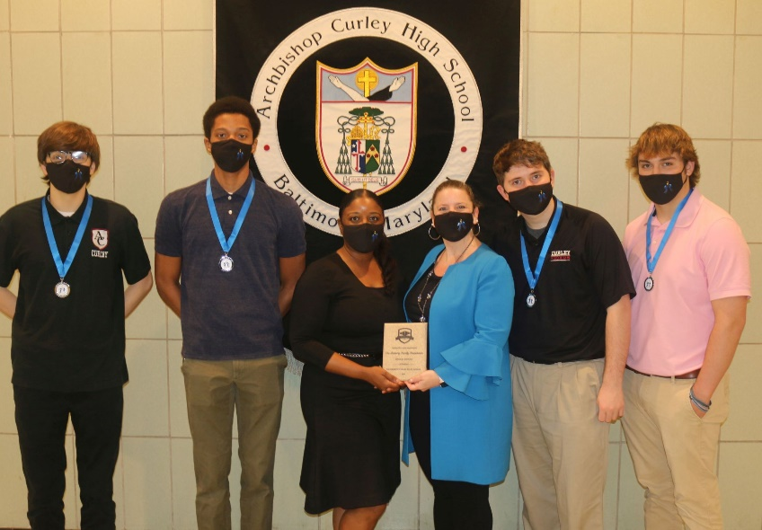
The Flaherty Foundation (Mission Support) represented by Ms. Beth Flaherty, the Foundation’s Executive Director, and Ms. Tiffany Scurlock, the Regional Scholarship Facilitator. Ms. Flaherty and Ms. Scurlock posed with the senior scholarship recipients.
The Flaherty Family Foundation began in Minnesota, but then expanded to the Baltimore-Washington area, and partnered with Curley beginning in 2017. The Foundation identifies high school students with potential, and works them throughout their years to reach the goal of graduation, acceptance into college, and beyond. Currently they sponsor 29 Curley men across all grades.

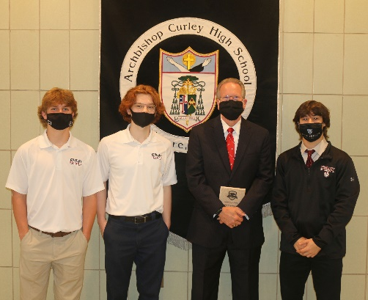
Mr. Robert ’73 & Mrs. Eileen Jirsa, Mrs. Joan Jirsa (Scholarship Donors). Mr. Jirsa later posed with the recipients of the Jirsa Scholarship.
For almost 30 years Robert Jirsa, a member of the Class of 1973, and his wife Eileen, have been generous contributors to Curley. In 2005, together with Mrs. Joan Jirsa, they established the Robert C. Jirsa Memorial Scholarship, and they have continued to grow it in value. In addition, they have also supported Curley’s capital campaigns, the Gala, the Annual Fund and the St. Joseph Fund. Bob has also served as the chair of the Curley School Board, and as chair of the school’s 50th Anniversary Committee. He is a current member of the capital campaign committee. On this Curley Cornerstone Day, the school is pleased to honor Mrs. Joan Jirsa and Mr. and Mrs. Robert Jirsa as Scholarship Donors, but also for all their philanthropic support of the Curley mission.

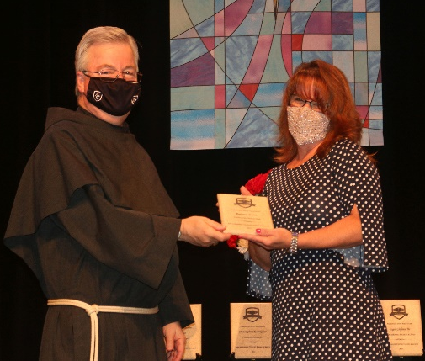
Mrs. Barbara Suehle (Dedicated Volunteer).
Barbara Suehle is the wife of Joseph, a member of Curley’s Class of 1983, and mother of two alumni sons, graduates of 2015 and 2017. During her sons’ years at Curley Mrs. Suehle assisted in the Campus Store, became involved with the Parents Guild as a class parent, and began to help with the Curley Gala. She has remained a committed volunteer for the Gala even as her sons have moved on, and in fact Mrs. Suehle is the main force behind recording and organizing the gifts for the Gala, an effort that begins months before the actual event. In 2020 she joined Curley’s School Board. On this Cornerstone Day, Barbara Suehle is honored as a Dedicated Volunteer.

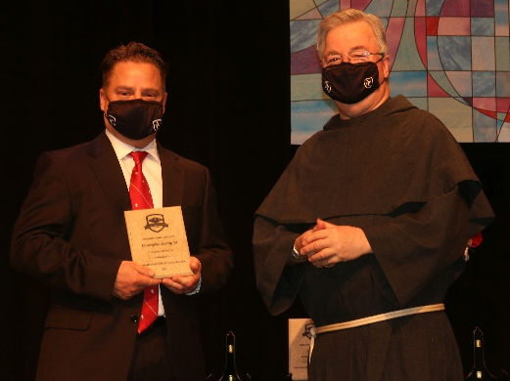
Mr. Christopher Ludwig ’91 (Unsung Alumnus)
Christopher Ludwig, who graduated in 1991, made his first Annual Fund gift in 1993, and has been a steady donor with gifts of increasing value, as well as supporting two capital campaigns, scholarships and special projects. But Chris not only contributes financially to Curley, he also contributes his time and expertise. He has served on the Alumni Board, including Alumni Association president from 2012 to 2014 when he was also on the School Board, and is a member of the committee for the current capital campaign, Renewing Our Future. Much of Chris’ work has been behind the scenes, helping his alma mater in so many different ways. As such it is a pleasure to honor Christopher Ludwig today with the “Unsung Alumnus” award.

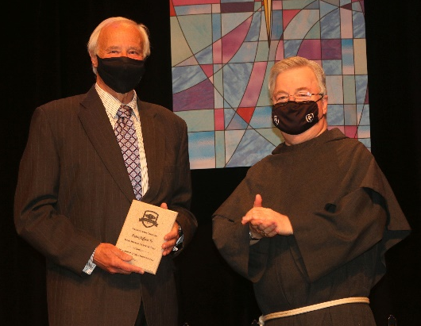
Mr. Eugene Hoffman ’69 (Long Serving Faculty & Staff)
Mr. Hoffman, a member of Curley’s 5th graduating class in 1969, began coaching at Curley in 1975, and then joined the faculty in 1977. Over the years Mr. Hoffman has taught physical education, health and algebra, and spent some137 seasons coaching cross country, indoor track, and track and field. Along the way he has made such a mark on the athletic community that the MIAA’s Track & Field Championship award is named for him. Mr. Hoffman retired in 2020, but has continued to help with coaching this year, and one expects his presence will be around well into the future. For all his years of service, both inside and outside the Curley building, in the category of long-serving faculty and staff, Mr. Gene Hoffman is honored with a Cornerstone Award.

