Use the lessons links (underlined section titles) to complete the following practice questions. Show your work. Do NOT use a calculator.
- Factors and Primes
A) Divisibility Rules:
- Is 378 divisible by 2?
- Is 729 divisible by 10?
- Is 590 divisible by 5?
- Is 540 divisible by 3?
- Is 982 divisible by 9?
- Is 689,531 divisible by 4?
- Is 73,232 divisible by 8?

B) Primes and Factors:
Use factor trees to find the prime factorizations of:
    - 88 b. 48

    - 378 d. 16,500

- Fractions

- $\frac{1}{2}+\frac{1}{3}$ =

- $\frac{1}{6}-\frac{7}{12}$ =

- $\frac{-2}{5}×\frac{10}{11}$ =

- $\frac{-1}{3}÷\frac{-4}{9}$ =

- $4\frac{1}{2}+5\frac{1}{5}=$

- $\frac{7}{15} ÷ \frac{9}{10}=$

- Decimals
Change the following from fraction to decimal or from decimal to fraction, as indicated:
a. $\frac{7}{8}$ = b. $\frac{18}{81}$ = c. $\frac{14}{21}$ =

d. 0.15 = e. 0.35 = f. 0.325
- Percents
  - Convert 50% to a fraction. d. Convert $\frac{25}{40}$ to a percentage

  - Convert 80% to a fraction. e. Convert $\frac{14}{35}$ to a percentage

  - Convert 14% to a fraction. f. Convert $\frac{42}{60}$ to a percentage

- Signed Numbers (Integers)
    - 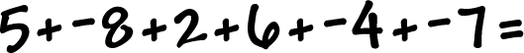

    - 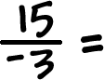

    - 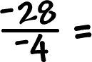

- Intro to Exponents
Simplify (rewrite)

- 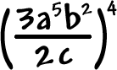 b. 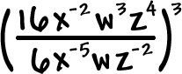
- Intro to Radicals
Simplify:
- 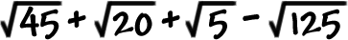 =

- 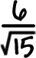

- 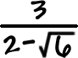

- Intro to Polynomials
- =

- =

- 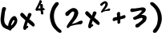 =

- Intro to Solving Equations – Solve for x

- 